Interest Rate Uncertainty and the Macroeconomics in Turkey
Pelin ÖGE GÜNEY

Abstract
Monetary policy has a central role in stabilizing macroeconomic fluctuations. In addition to monetary policy, uncertainty about monetary policy associated with uncertainty in interest rate is an important determinant of economic decisions. In this paper, we analyzed the effect of interest rate uncertainties for different maturities on industrial production, inflation, unemployment, and exchange rate using the VAR model. Due to the dominant position of the US economy in global financial markets, in addition to countries’ own uncertainties, uncertainty about the monetary policy of the US may have an impact on other economies. We also discussed the impact of uncertainty about US monetary policy on the mentioned variables of Turkey. Although the effect varies across different maturity of the yield, our findings suggest that interest rate uncertainty reduces the growth of industrial production, increases unemployment and depreciates the exchange rate. Additionally, inflation increases in response to interest rate uncertainty shocks. Finally, according to our results, while a shock in uncertainty about US monetary policy tends to significantly increase unemployment, it decreases the growth of production.
Keywords: Uncertainty, Interest rate, VAR model, Macroeconomics.
JEL Clasiffication: E43, E52, E58

1. Introduction
Monetary authorities can affect the behavior of economic agents by changing the interest rate and the uncertainty in the interest rate can be associated with the uncertainty in monetary policy. That is, uncertainty in monetary policy implies potential future changes in interest rates.
In general, uncertainty influences the decisions about consumption, investment, trade or employment. Uncertainty in the interest rate can be expected to affect the economy in various ways. For example, uncertainty in interest rates leads to an increase in the risk of holding bonds. In this situation, economic agents prefer to increase their money holdings, and as the money demand increases interest rates increase. Higher levels of interest rates reduce investment and output. In addition, interest rate uncertainty in a country makes that economy’s debt riskier and discourages capital inflows. Central banks try to ensure that the public has more accurate expectations about the future course of monetary policy and interest rates by following transparent policies. Reduced uncertainty about interest rates allows for a more accurate estimation of financial costs. Thus, the decrease in risk perception of the public positively affects investment decisions and firm hiring activity.
Although traditional wisdom is that reducing volatility about the future direction of interest rate has a positive impact on the economy, the effect of the uncertainty in the interest rate may differ according to the economic and institutional structures of the countries. For example, countries whose economies rely on manufacturing industries that require long-term projects are more sensitive to interest rate uncertainty. Or, in countries with strict labor market regulations, it is difficult to lay off according to changes in expectations. On the other hand, by using the same data, economic decision-makers may have different expectations about how interest rates will change in the future. In this paper, we empirically investigate the relationship between interest rate uncertainty and macroeconomic variables for Turkey.
In Turkey, since the 2001 crisis, transition to inflation targeting was launched and implicit inflation targeting was adapted from January 2002 to December 2005. The explicit inflation targeting regime started to be implemented in January 2006. In this policy framework, the main policy tool is the short-term rates. Following the implementation of inflation targeting, the link between interest rate and spending decisions has strengthened (see Başçı, Özel, and Sarıkaya (2008) and Kara et al. (2007)). Although the monetary policy transmission mechanism for Turkey is widely investigated (see Us (2004); Aydın (2007); Kara et al. (2007); Başçı et al. (2008) among others), to the best of our knowledge the effect of interest rate uncertainty on macro variables is not analyzed.
With the experience of the recent global crisis, the Central Bank of the Republic of Turkey (CBRT) has been implementing a new monetary policy concerning both financial stability and price stability. The new policy tools like the interest rate corridor have been adopted to achieve these goals. According to this policy, the policy interest rate of the CBRT fluctuates within the band and the central bank has the ability to increase uncertainty on the future path of the policy rate by widening this corridor. This policy is already a source of uncertainty on its own. In addition to this policy change, other factors also lead to uncertainty in monetary policy in Turkey. These factors can be listed as follows: frequent changes of the CBRT governor, interest rate cuts to support economic growth through consumption, interventions in the foreign exchange market. From this point of view, in this study, we investigate the relationship between uncertainties in the interest rates and macroeconomic variables in Turkey. Understanding how interest rate uncertainties affect macroeconomic variables can be a guide for central banks in planning monetary policies.
In addition to countries’ own monetary policies, Federal Open Market Committee’s (FOMC) monetary policy decisions are closely followed by investors around the world, due to the countries' trade integration and financial links with the US. Besides, the dominant position of the US economy in global financial markets causes economies that are not geographically close to the US or less integrated in terms of trade to be affected by US monetary policy. Lastauskas and Nguyen (2021) state that monetary policy uncertainty can be the source of global business cycles. Considering the arguments that the uncertainties regarding the US monetary policy significantly affect other economies, we also investigated the effects of the uncertainty about the monetary policy of the US (MPU) on the Turkish economy. To the best of our knowledge, this effect has not been analyzed for Turkey in previous studies.
According to our findings, the immediate impact of a shock in policy rate uncertainty on the exchange rate is depreciation. Following, the exchange rate temporarily appreciate. Uncertainty in the 10-year yield has a similar impact on the exchange rate. That is, uncertainty in the interest rates causes volatility in the real exchange rate. If we consider inflation, we observe that shocks of interest rate uncertainty leads to an increase in inflation. The effect of uncertainty on the policy rate is quantitatively more important and long-lived then uncertainty in longer yields. We see that the response of the growth of industrial production to uncertainty in the 2-and 10-year yield shocks are negative. Additionally, we observe that unemployment worsened in response to a shock in 2-year yield uncertainty. Finally, we consider the response of Turkish macroeconomic variables to a shock in US monetary policy uncertainty. We find that a shock in uncertainty about US monetary policy increase unemployment, and decreases the growth of production.
The outline of the paper is organized as follows. In Section 2, we present the existing literature. The methodology is provided in Section 3. In Section 4 we present estimation results. Finally, in the last section, we discuss policy implications and provide concluding remarks.

2. Literature Review
There is a growing empirical and theoretical literature that investigates the effect of uncertainty on macroeconomic variables and monetary policy. (see Bloom (2009); Bake, Bloom and Davis (2015); Aastveit, Natvik and Sola (2013); Fernandez-Villaverde et al. (2011), Bekart, Hoerova and Lo Duca (2013); Ludvigson, Ma, Ng (2015); Ulrich (2012); Pastor and Veronesi (2012); Öge Güney (2016) among others). Besides, some of the limited numbers of studies analyze the macroeconomic effects of uncertainty in interest rates. For example, Creal and Wu (2017) investigated the relationship between uncertainty about the interest rate and selected macro variables for the US. They decompose the long-term interest rate into two components as risk premium uncertainty and monetary policy uncertainty. Using a VAR model they show that uncertainty has a negative effect on economic activity. In addition, they found that monetary policy uncertainty and term premium uncertainty react in opposite directions to the unemployment rate. Istrefi and Mouabbi (2016) analyzed the impact of uncertainty about the short and long-term interest rates on the economy for ten developed countries. According to their findings, interest rate uncertainty have a negative effect on unemployment and industrial production. In addition, they showed that uncertainty about short-term rates has stronger quantitative effects on the economy relative to uncertainty about long-term rates. Using a vector autoregression Bundick, Trenton, and Smith (2017) found that declines in uncertainty in the interest rate lead to an increase in industrial production and inflation for the USA.
Fasolo (2019) found that an increase in monetary policy volatility, meaning unexpected decisions about interest rates, causes higher inflation and lower output in Brazil. In addition, according to his findings, unexpected changes in monetary policy depreciate the exchange rate. Contrary, Benigno et al. (2012) provided evidence that monetary policy volatility shocks cause an appreciation of the domestic currency. Using an SVAR model, Mumtaz and Zanetti (2013) showed that monetary policy volatility shocks have a positive correlation between prices and output level for the US. Mumtaz and Theodoridis (2020) showed that monetary policy shocks increase macroeconomic volatility. Husted et al. (2017) showed that a greater monetary policy uncertainty raises credit cost and reduces output.
Some papers analyze the impact of uncertainty in US monetary policy on other economies. Park et al. (2020) showed that uncertainty about US monetary policy tends to increase the volatility in the exchange rate for some Asian economies. Bhattarai et al. (2020) emphasized that US stock market uncertainty has an adverse effect on some macroeconomic variables such as exchange rate, output, and inflation in emerging countries. Lastauskas and Nguyen (2021) stated that US interest rate uncertainty can be the source of global business cycles. According to their findings, the magnitudes of the negative effect of monetary policy uncertainty on economies depend on cross-country interdependence. Lakdawala et al. (2021) showed that US monetary policy uncertainty has a significant effect on global bond and equity markets. Also, they found that in developing countries the response to uncertainty is closely related to a country's financial openness.
For Turkey, there are a few studies in the literature regarding monetary policy uncertainty. Aktaş et al. (2009) investigate the effect of policy rate changes on financial markets by separating monetary policy into expected and unexpected components. They showed that monetary surprises have a significant effect on financial markets. Çevik and Erduman (2020) construct a survey-based measure of monetary policy uncertainty for Turkey. Then, they find that uncertainty about monetary policy has a negative effect on economic activity in Turkey.

3. Methodology and Analysis:
The main question of our study is whether the interest rate uncertainty is a matter for the Turkish economy. For this aim, we investigate the responses of growth of industrial production, inflation, unemployment, and exchange rate to interest rate uncertainties for different maturities.
Following the recent literature that investigates the relationship between uncertainty and the macroeconomy, we use VAR model and impulse responses (e.g. Baker, Bloom, and Davis (2016); Jurado, Ludvigson, and Ng (2015); Bekaert, Hoerova, and Lo Duca (2013); Aastveit, Natvik, and Sola (2013); Creal and Wu (2017)). This method allows examining the interaction of variables with each other. In addition, necessary constraints can be placed on the model.
The VAR model is presented as

$$z_{t}={A_{0}+A}_{1}z_{t-1}+…+A_{p}z_{t-p}+u_{t}$$
$$t=1,…, T$$
$A_{i}$ is (nxn) matrix. u represents (nx1) vector of error terms. $z_{t}$ is (nx1) vector of time series. $p$ represents maximum lag in the VAR model. The lag length is selected based on the Akaike Information Criterion. $E\left(u_{t}\right)=0$, $E\left(u_{t},u_{t}^{'} \right)=θ$, $E\left(u_{t},u_{t-k}^{'} \right)=0$ for any non-zero k.
$z_{t}=(INF, IP, REXC,UNEMP, OIL, Uncertainty measures)$
Our VAR model includes the interest rate uncertainty measures, industrial production (IP), inflation rate (INF), exchange rate (REXC), and the unemployment rate (UNEM) as endogenous variables. In addition, we include oil prices (OIL) as an exogenous variable. We use a CPI-based real effective exchange rate. Since the real effective exchange rate and unemployment variable are non-stationary at level, we use the first difference of their log. We use the log of seasonally adjusted industrial production series. Percentage change in Consumer Price Index presents inflation series. Data on crude oil prices in U.S. dollars per barrel are the price of Dubai Fateh crude oil. We focus on different yield uncertainties. Firstly, we use the central bank policy rates as a measure of short-term interest rates (unc_policy rate). In addition, we use 2-year Treasury Bill rates (unc_2Y bond yield). Because 2-year Treasury Bill rates are accepted as a benchmark interest rate in Turkey. Following Istrefi and Mouabbi (2016), we use 10-year Treasury Bill rates as a measure of long-term interest rates (unc_10Y bond yield).
To investigate whether the uncertainty in US monetary policy is a matter for the Turkish economy, we use the MPU index for the US economy obtained from Baker, Bloom, and Davis (2016) (mpuusa). To construct the MPU index, they identified the occurrence of certain keywords in newspaper articles.
In the literature, different methods are used to measure uncertainty (see Lensink, 2002). Since the advantages (see Grier and Perry 2000), and following Caporale and McKiernan (1998) we use the generalized autoregressive conditional heteroskedasticity (GARCH) models to measure uncertainty in the interest rates. We use the following GARCH model provided by Bollerslev (1986) to achieve the interest rate uncertainty series. The time-varying variance of the unforeseen part of the GARCH model (h_{t}) is taken as uncertainty. It is assumed that h_{t} is a linear function of past squared errors and past variances.

$y_{t}=β_{0}+\sum_{j=1}^{q}{β_{j}y_{t-1}}+ε_{t}$ (1)
$h_{t}^{2}=α_{0}+α_{1}ε_{t-1}^{2}+α_{2}h_{t-1}^{2}$ (2)

where $y_{t}$ is the variable the volatility of which we desire to find, $ε_{t}$ is stochastic processes with zero mean. $h_{t}$ is conditional variance of interest rate.
Since implicit inflation targeting started to be implemented at the beginning of 2001, we use monthly data from 2002:01 to 2020:12. The data are gathered from International Monetary Fund-International Financial Statistics (IFS) and the CBRT’s Electronic Data Delivery System (EDDS). The data of 2-year and 10-year government bond rates are obtained from investing.com. MPU index for the US economy is obtained from Baker, Bloom, and Davis (2016). Since the data availability, our VAR model with 2-year and 10-year government bond rate uncertainty covers the period 2006M11-2020:12 and 2010:02-2020:12, respectively.

4. Empirical Results:
For the VAR model to be applied, all variables included in the model must be stationary. The results of the unit root tests of the variables are presented in Table 1.
Table 1. ADF Unit Root Test Results
 | Intercept | Trend and Intercept | No Trend and No Intercept
INF | -9.432* | -9.004* | -6.174*
IP | -15.793* | -15.763* | -15.560*
REXC | -11.754* | -11.886* | -11.712*
UNEMP | -4.219* | -4.284* | -4.189*
OIL | -10.164* | -10.230* | -10.176*
unc_policy rate | -5.236* | -5.431* | -0.636
unc_2Y bond yield | -11.229* | -11.199* | -11.255*
unc_10Y bond yield | -9.733* | -9.693* | -9.751*
mpuusa | -7.463* | -7.473* | -2.756*
Note: * denotes the significance of the coefficient at the 1% level.

The effects of different yield uncertainties on the real exchange rate, inflation, industrial production, and unemployment were assessed by impulse response functions. The ordering in computing impulse responses was real exchange rate, interest rate uncertainty, inflation, industrial production, and unemployment rate, assuming that the real exchange rate is the most exogenous variable in the model. However, our results were not affected when we changed the ordering of the variables.
We provide the impulse response functions in Figure 1. The dotted lines show the two standard error bands used as a measure of statistical significance. We presented the impulse responses to innovations to uncertainty in the policy rate, and two and ten-years treasury bill rates in the first, second, and third columns, respectively.
As the figure evidence, an unexpected increase in policy rate uncertainty causes volatility in the real exchange rate. In response to this uncertainty, the real exchange rate temporarily depreciates within the two months the shock hits. Following, increases in policy rate uncertainty lead to a temporary appreciation of the real exchange rate. Similarly, uncertainty in long yield causes an immediate but short-lasting depreciation in the real exchange rate followed by weak and short-lasting appreciation. However, the appreciation effects are not statistically significant. On the other hand, the effect of uncertainty in 2-year treasury bill rates on the real exchange rate is not different from zero.
Figure 1. Impulse Responses to Interest Uncertainty Shock
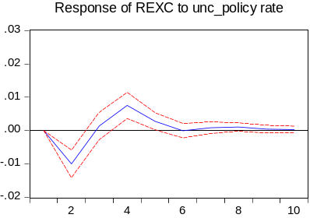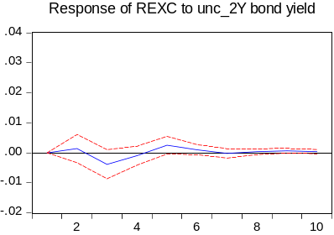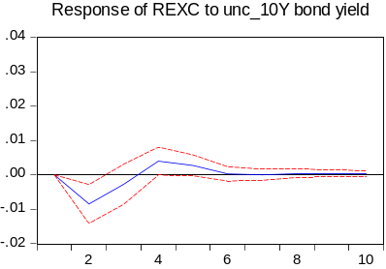

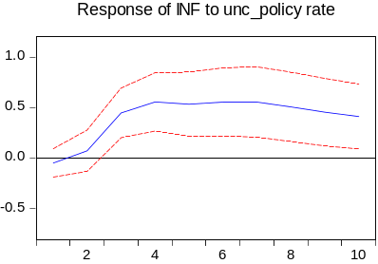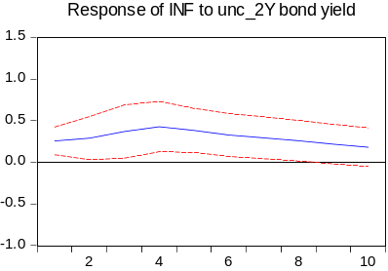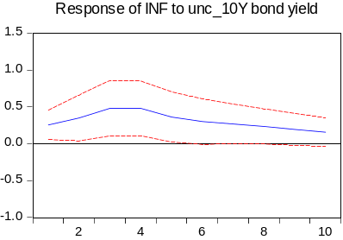

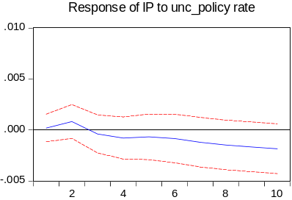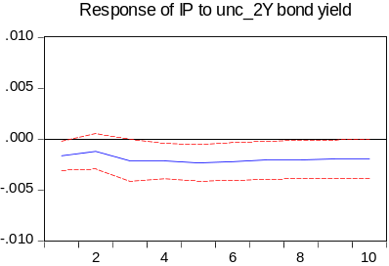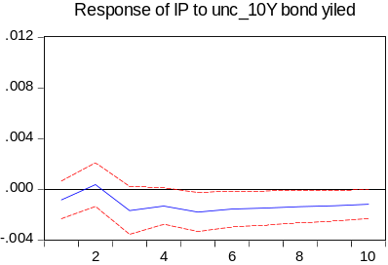

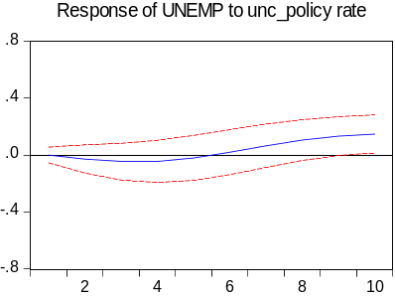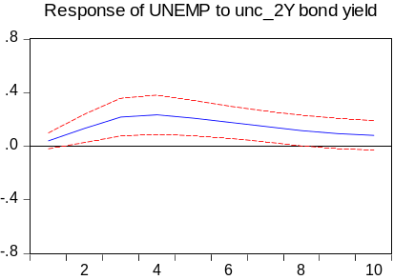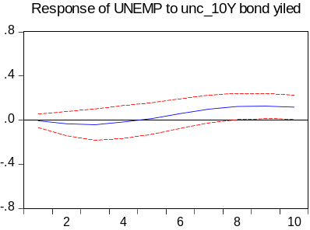
Note: Figure presents the response of the Turkish macroeconomy to a shock in the interest rate uncertainty for different yields. The dotted lines show the two standard error bands used as a measure of statistical significance. VARs include a constant, a time trend, and oil prices as an exogenous variable. Horizontal axis is in months.

As can be seen from the second row of Figure 1, the inflation rate increases following a positive policy rate uncertainty shock. The response takes three months to reach its maximum level and remain effective for a long time. Inflation responds immediately and positively to uncertainty in 2-year and 10-year yield shocks, with rates increasing around 0.5 percentage points after three months to these shocks. The response to the 2-year yield shock is significantly positive up to seven months. The effect of uncertainty on the 10-year yield shock is relatively short-lived.
We observe that a positive policy rate uncertainty shock causes a short-lived increase in the growth of industrial production followed by a long-lasting decline. However, the effects of policy rate uncertainty shock on the growth of industrial production are not statistically significant. Growth of industrial production responds negatively to the uncertainty in the long yield shocks, and these responses are statistically significant from three-four months after the shocks. It seems that, despite significant, the decline in growth of industrial production does not quantitatively relevant.

Figure 2. Impulse Responses to US Monetary Policy Uncertainty Shock
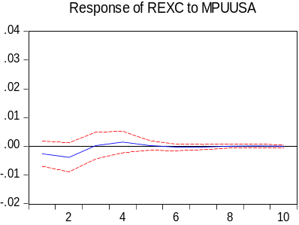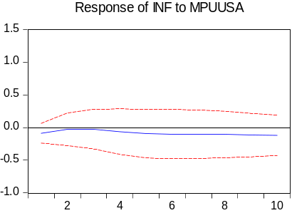

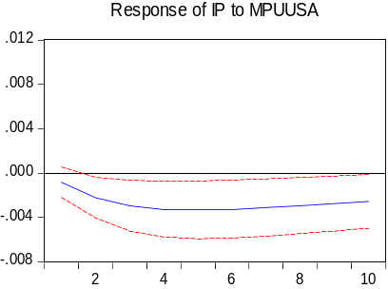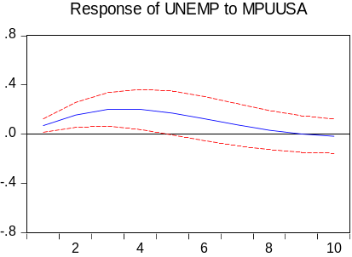
Note: Figure presents the response of the Turkish macroeconomy to a shock in US monetary policy uncertainty. The dotted lines show the two standard error bands used as a measure of statistical significance. VARs include a constant, a time trend, and oil prices as an exogenous variable. Horizontal axis is in months.

If we look at the effect of shock in the interest rate uncertainty on unemployment, it is seen that when there is a shock in the policy rate uncertainty, it leads to a decrease in unemployment for up to five months. However, this effect is statistically insignificant. About eight months after the shock, the unemployment rate responds positively and significantly to the uncertainty shock, with a rate of approximately 0.15 percentages. The response of the unemployment to a 10-year treasury bill uncertainty shock displays similar dynamics. The response is insignificantly negative up to four months. About seven months after the shock, the unemployment rate responds significantly and positively to the long-yield uncertainty shock. In the case of an uncertainty shock in the 2-year yield, the unemployment rate immediately responds with an increase and this response continues for seven months. That is, unemployment worsens in response to a shock in interest rate uncertainty.
Figure 2 provides the impulse responses of the real exchange rate, industrial production, inflation, and unemployment to US monetary policy uncertainty shock. We observe that the effect of US monetary policy shock on inflation and real exchange rate are not different from zero. In the case of industrial production, we see that the reaction of growth of industrial production to MPU shock is negative and long-lived. Finally, we observe that unemployment reacts by a rise of 2 percentage points to MPU shock. This impact on unemployment is in the short-term, which turns insignificant after 4 months following the shock.

5. Policy Implications and Conclusion:
To make economic decisions, the expected outcomes of these decisions are generally taken into account and people need to have a vision of what the future will be like. While uncertainty about the future is always present, large increases in uncertainty can make forward-looking decisions even more difficult. These uncertainties do not only arise from countries’ own uncertainties but also uncertainties from abroad. Due to the dominant position of the US economy in global financial markets, uncertainty about the monetary policy of the US (MPU) may have an impact on other economies. Our study presents the macroeconomic implications of uncertainties regarding Turkey’s own interest yields and the MPU of the US.
According to our findings, although it does not quantitatively relevant, shocks to long-yield uncertainties have a negative effect on the growth of industrial production. In addition, unemployment worsens in response to a shock in interest rate uncertainty. The response of unemployment to 2-year yield uncertainty is high in magnitude and persistent. It seems that interest rate uncertainty is recessionary, that is, it increases unemployment and decreases economic growth. When we consider the inflation rate, we observe that inflation increases in response to interest rate uncertainty shocks. The effect of policy rate uncertainty on inflation is quantitatively large. If we look at the response of the exchange rate, we observe that uncertainty in the interest rates causes volatility in the real exchange rate. Overall, our results put forth the importance of reducing uncertainties about interest rates to achieve economic stability.
Finally, we observe that US monetary policy shock leads to a long-lived decline in the growth of industrial production. Besides, unemployment increases following an MPU shock. These findings indicate that US monetary policy uncertainty can be one of many sources of the decline in output growth and the increase in the unemployment rate for Turkey. This may be due to the fact that US monetary policy uncertainty is seen as a source of uncertainty by investors in Turkey. The degrees of trade and financial integration with the US may lead this response.
To reach their goals, the central banks should be able to influence expectations regarding the future path of the interest rate. However, uncertainties in the interest rate can weaken this effect. If interest rate uncertainties represent a negative element for the effectiveness of the monetary policy, we can conclude that our findings provide evidence for the importance of transparency, clear communication, and accountability of central banks. That is, central banks can use these tools to alleviate interest rate uncertainty. Mishkin (2000) examined the principles that central banks should follow in order not to cause uncertainty. Accountability, transparency, and communication are some of those principles. By reducing the uncertainty in the interest rate, economic agents can be enabled to plan, invest and trade with little need for hedging.
Although the central bank's clear communication with the public has an important role in reducing the uncertainty about the future path of interest rates, the central bank may not be able to implement its plans due to unexpected macroeconomic developments. Most economic policies respond to underlying economic conditions. Therefore, it is impossible to be sure exactly what the policy will be if there is uncertainty about the underlying conditions. While it is impossible to eliminate all economic uncertainty, it can be helpful to set clear policy targets. At least in this case monetary policy itself will not be a source of uncertainty.

References
Aastveit, K., Natvik, G.J. and Sola, S. (2013) “Economic uncertainty and the effectiveness of monetary policy." Unpublished manuscript, Norges Bank.
Aktaş, Z., Alp, H., Gürkaynak, R., Kesriyeli, M., and Orak, M. (2009) “Türkiye'de para politikasının aktarımı: Para politikasının mali piyasalara etkisi.” İktisat İşletme ve Finans, 24(278), 9-24.
Aydın, H.İ. (2007) "Interest rate pass-through in Turkey," Working Papers 0705, Research and Monetary Policy Department, Central Bank of the Republic of Turkey.
Baker, Scott R., Nicholas Bloom, and Steven J. Davis. (2016) “Measuring economic policy uncertainty.” The Quarterly Journal of Economics. 131 (4): 1593–1636.
Başçı, E., Özel, Ö., and Sarıkaya, Ç. (2008, January). The monetary transmission mechanism in Turkey: new developments. In Participants in the meeting (p. 475).
Bekaert, G., Hoerova, M. and Duca, M.L (2013) “Risk, uncertainty, and monetary policy." Journal of Monetary Economics 60, 771-788.
Benigno, G., Benigno, P., and Nisticò, S. (2012) “Risk, monetary policy, and the exchange rate.” NBER Macroeconomics Annual, 26(1), 247-309.
Bhattarai, S., Chatterjee, A., and Park, W. Y. (2020) Global spillover effects of US uncertainty. Journal of Monetary Economics, 114, 71-89.
Bloom N. (2009) “The impact of uncertainty shocks”. Econometrica 77: 623–685.
Bollerslev, T. (1986) “Generalized autoregressive conditional heteroskedasticity.” Journal of Econometrics, 31(3), 307-327.
Bundick, B., Herriford, T., and Smith, A. (2017) “Forward guidance, monetary policy uncertainty, and the term premium.” Monetary Policy Uncertainty, and the Term Premium (July 2017).
Caporale, T., and McKiernan, B. (1998) “Interest rate uncertainty and the founding of the Federal Reserve.” The Journal of Economic History, 58(4), 1110-1117.
Creal, D.D., and Wu, J.C. (2017) “Monetary policy uncertainty and economic fluctuations.” International Economic Review, 58(4), 1317-1354.
Cevik, S., and Erduman, Y. (2020) Measuring monetary policy uncertainty and its effects on the economy: The Case of Turkey. Eastern European Economics, 58(5), 436-454.
Fasolo, A. M. (2019) Monetary policy volatility shocks in Brazil. Economic Modelling, 81, 348-360.
Fernandez-Villaverde, J., Guerron-Quintana, P., Rubio-Ramrez, J.F. and Uribe, M. (2011) “Risk matters: the real effects of volatility shocks." American Economic Review 101, 2530-2561.
Grier, K. B., & Perry, M. J. (2000) The effects of real and nominal uncertainty on inflation and output growth: some garch‐m evidence. Journal of applied econometrics, 15(1), 45-58.
Güney, P.Ö. (2016) “Does the central bank directly respond to output and inflation uncertainties in Turkey?.” Central Bank Review, 16(2), 53-57.
Husted, Lucas, John H. Rogers, and Bo Sun. (2017) “Monetary policy uncertainty.” International Finance Discussion Papers. Board ofGovernors of the Federal Reserve System. (1215).
Istrefi, K., and Mouabbi, S. (2018). “Subjective interest rate uncertainty and the macroeconomy: A cross-country analysis.” Journal of International Money and Finance, 88, 296-313.
Jurado, K., Ludvigson, S.C., and Ng, S. (2015) “Measuring uncertainty." American Economic Review 105, 1177-1216.
Kara, H., Küçük-Tuğer, H., Özlale, Ü., Tuğer, B., and Yücel, E. (2007) “Exchange rate regimes and pass-through: Evidence from the Turkish Economy.” Contemporary Economic Policy, 25 (2), 206–225.
Lakdawala, A., Moreland, T., and Schaffer, M. (2021) The international spillover effects of US monetary policy uncertainty. Journal of International Economics, 133, 103525.
Lastauskas, Povilas & Nguyen, Anh Dinh Minh, (2021) "Global impacts of US monetary policy uncertainty shocks," Working Paper Series 2513, European Central Bank.
Lensink, R. (2002) “Is the uncertainty-investment link non-linear?” Review of World Economics, 138(1), 131-147.
Ludvigson S.C., Ma, S., Ng, S. (2015) “Uncertainty and business cycles exogenous impulse or endogenous response?” NBER Working Paper 21803, NBER Working Paper.
Mishkin, F. S. (2000). “What should central banks do?.” Review, Federal Reserve Bank of St. Louis. 82(Nov), 1-14.
Mumtaz, H., and Zanetti, F. (2013) The impact of the volatility of monetary policy shocks. Journal of Money, Credit and Banking, 45(4), 535-558.
Mumtaz, H., and Theodoridis, K. (2020) Dynamic effects of monetary policy shocks on macroeconomic volatility. Journal of Monetary Economics, 114, 262-282.
Park, D., Qureshi, I., Tian, S. et al. (2020) “Impact of US monetary policy uncertainty on Asian exchange rates”. Econ Change Restruct. https://doi.org/10.1007/s10644-020-09307-3
Pastor, L., and Veronesi, P. (2012) “Uncertainty about government policy and stock prices.” The journal of Finance, 67(4), 1219-1264.
Ulrich, M. (2012) “Economic policy uncertainty and asset price volatility" Unpublished manuscript, Department of Economics, Columbia University.
Us, V. (2004) “Monetary transmission mechanism in Turkey under the monetary conditions index: an alternative policy rule.” Applied Economics, 36:9, 967-976, DOI: 10.1080/0003684042000233195

Prof. Dr., Hacettepe University, Faculty of Economics and Administrative Sciences, Department of Economics, pelinoge@hacettepe.edu.tr
To test the robustness of the results, we used another measure for interest rate uncertainty obtained from the CBRT's survey of expectations. We took the series of the standard deviation of the expected policy rate. Since the data availability, our VAR model covers 2010M6-2020:10. This estimation did not cause a significant change in our results.

