Egypt’s National Road Project:
Assessing the Economic Impacts of the Upgraded Transportation Network
Dina N. Elshahawany, Eduardo A. Haddad, & Michael L. Lahr

Abstract. In 2014, Egypt started its National Road Project. This project is one of the greatest achievements realized in the history of the Egyptian roadways, perhaps even of all infrastructure. It is designed to connect the nation’s governorates via about a 30% expansion of the existing network of 23,500 kilometers of roadways. Its costs currently are pegged at about US$9.8 billion. About two thirds of the National Roads Project plans are now in place; another 1,300 kilometers remain under construction. The final 1,200 kilometers are to be built in the near future. In this paper, we explore how the National Road Project likely has changed the country’s economy both nationally and regionally. We do so by applying a spatial computable general equilibrium (SCGE) model of Egypt. We find it has energized the national economy by more deeply engaging some of the least developed of Egypt’s governorates.

Introduction
Egypt’s growing population and dynamic economy have stretched the nation’s existing infrastructure over past decades. Moreover, motor vehicles remain the nation’s transport mode of choice, creating a particular need for more and better roadways. In response, Egypt’s government has spearheaded significant investment in the road system to help its people cope with future traffic that is being forecast (Oxford Business Group, 2021). The investments are reflected in Egypt’s “Vision 2030” in which the major collection of transportation improvements is labeled “the National Road Project”.
The National Roads Project is designed to increase the capacity of the transport sector and boost the nation’s international and regional transport volumes. Specifically, its designed to decongest the crowded and narrow Nile Valley by diverting long-distance traffic through and building new towns in less densely inhabited areas such as Western Desert and the New Valley (Egypt Independent, 2017). It is hoped the project will enable wealth by engaging mining, tourism, and other industry in these peripheral areas. In so doing, it should enhance productivity and production in agriculturally rich hinterlands. This latter is especially the case of the national reclamation project of 1.5 million acres.
The importance of the National Road Project can be highlighted by estimating the magnitude of the project economic impacts on Egypt’s economy. Such work can show how the project affected the economic development of specific locales as well as regions in which they are located.
We employ a modeling framework that has already enhanced the Egyptian Government’s analytical capabilities in fostering sustainable regional growth in Egypt (Haddad et al., 2016; Elshhawany, Haddad, and Lahr, 2017). The model enables rigorous analysis for use by decision makers.
Figure 1. The National Road Project.
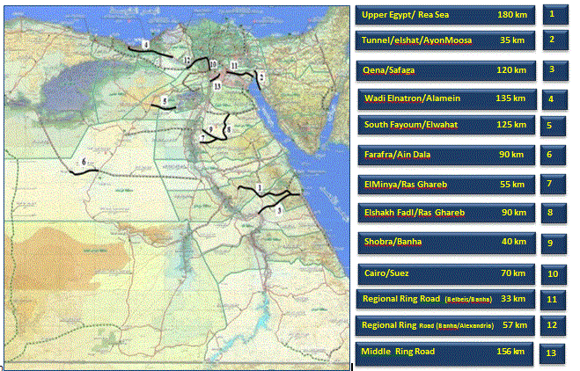
Source: The Ministry of Transport (2018).
Using the model, we will investigate the impact of The National Road Project as built to date, on Egypt’s economy at both national and regional level. We use the change in travel time and accessibility as enhanced by the project during the last six years. We use an ICGE model of Egypt that is specifically designed to estimate the impacts of road projects.

The National Road Project
Since 2014, Egypt has been implementing a large, transportation infrastructure plan—the National Road Project (see Figure 1). This project is one of the largest yet in the modern Egypt’s transportation history. It will enhance the road transportation network from its current 23,500 kilometers to around 30,500 kilometers at a total cost about US$9.79 billion. The project has three phases. The first includes 12 new roads with a total length 3,400 km. Four more roads comprise phase two, which adds about 1280 km as well as resurfacing and widening 2,500 km of existing roadways. Phase three, the construction of which is currently underway, adds six new roads with a total length of 1300 km. In essence about 4,580 of the 7,000 kilometers planned as the National Roads Project are already being used (AkbarElyoum, 2021). The most important roads are shown in Figure 1: the Upper Egypt/Red Sea Road (180 km), the Shobra/Banha Road (40km), the Regional Ring Road (400 km), the Elgalala Road (82 km), and the Elfarafra/Ain Dala Road (90km).

Travel Time Savings Induced by the National Road Project
Roadways are built and maintained to improve an economy’s productivity, and not for the sake of their construction effort, which can be substantial in some localities. That is, the principal benefit of transportation projects is that they reduce transportation times. As discussed in our prior work, we use GIS information of the road network and Google Maps to derive estimates of travel times. We did so by examining times on minimum impedance paths, in terms of hours, across the prime cities of Egypt’s governorates.
Figure 2 shows the aggregate time savings by governorate obtained after the construction of phase 1 and phase 2 and part of phase 3. Total travel time saving across all governorates is about 350 hours between every governorate and the other 26. Most of these travel-time savings accrue to poorer peripheral governorates that are most distant most from Egypt’s urban core. To trace economic benefits from travel-time reductions as effected by the National Road Project, we next highlight some of the new roads and their effects on travel time among the governorates.
Figure 2. Aggregate Travel Time (in hours) Savings by Governorates
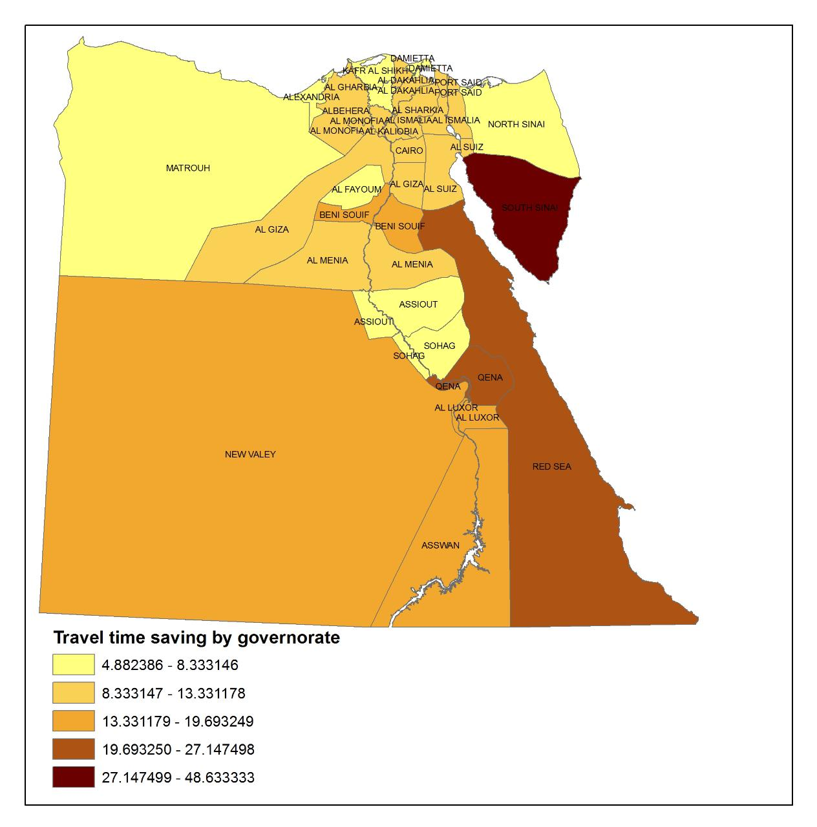
Source: Map created using ArcMap
.

3.1 The Upper Egypt – Red Sea Road
The greatest travel time savings—48.6 hours—were gained by south Sinai governorates. About half of these savings were garnered via the “Upper Egypt – Red Sea Road” (Figure 3.). This 180 km roadway connects Upper Egypt governorates to Red Sea governorates. The roadway was widened to two lanes (7.5 meters wide in total) at a cost of E£848 million. Figure 3.2 shows the distance and travel time of a trip using this new road link (between the capital cities of South Sinai and Sohag governorates). The Google Map estimates suggest that, due to the Upper Egypt–Red Sea Road, the distance between the two end points decreased 37% from 884 km to 543 km and the travel time between them decreased by 2.15 hours.
Figure 3. The Upper Egypt – Red Sea Road.
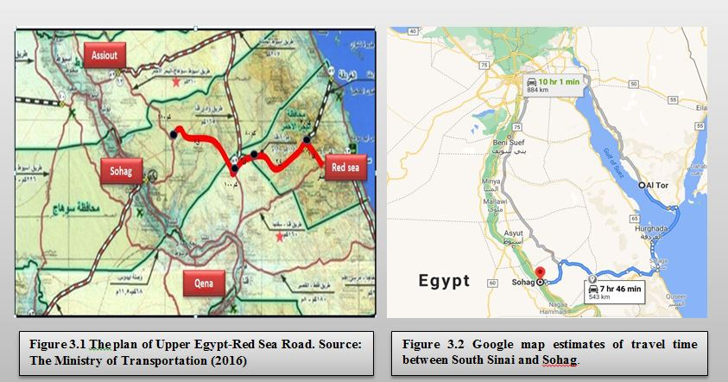 Source: The Ministry of Transport (2018).

3.2. The Regional Ring Road
Another important new road is the 400 km Regional Ring Road which connects seven governorates; Ismailia, Suez, Sharkeya, Qaliobya, Monofya, Giza, Fayom with the Cairo governorate (Figure 4.). According to the General Authority of Roads, Bridges and Land Transportation statistics, the government will gain profits not less than LE1 billion from the Regional Road (Egypt Independent, 2018). The road will help in increasing the trade movement between Upper Egypt, Delta and Suez Canal governorates and reducing traffic jams on the main road in Greater Cairo and the Ring Road. The road contributed to about 13 hours savings in travel time gained by the seven governorates.

Figure 4. The Regional Ring Road.
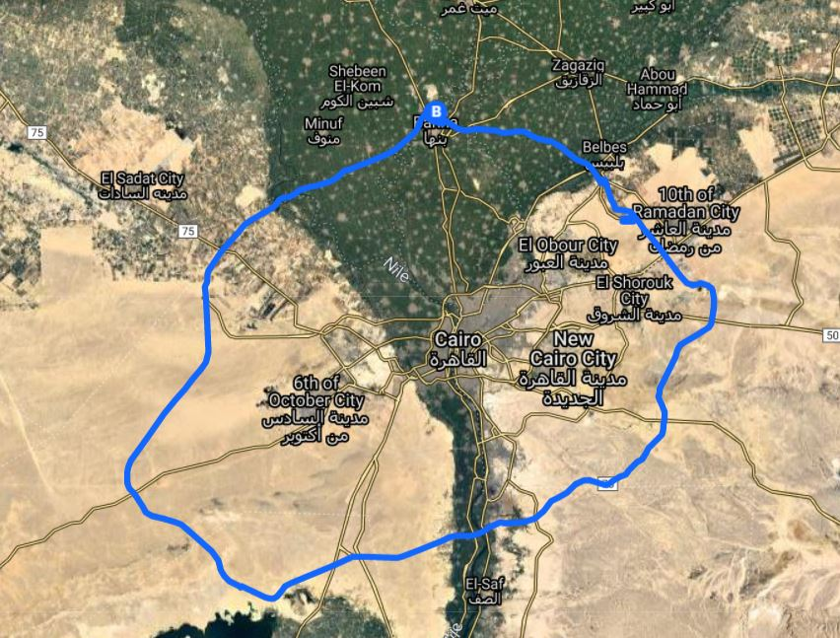
Source: Map created using Google Maps.

3.3 The Shobra – Banha free Road
The length of the road is 40 km, and its width is 41 meters. It includes four lanes, each with a width of 3.65 meters. The road includes 62 industrial works (38 bridges and 24 tunnels)—see Figure 5. The daily traffic volume is expected to reach 60,000 cars per day. The average travel time is 25 minutes, saving 65 minutes per trip.
The road was created with the aim of diverting traffic congestion from the ring road in Greater Cairo and the old “Shubra-Banha” road, it connects six main links: Greater Cairo Ring Road; the Regional Ring Road; the Benha-Mansoura Road; the Minya al-Qamh – Zagazig Road; and the Cairo-Alexandria Agricultural Road. This new road is of a special importance for the people of the governorates of Dakahlia, Sharkia, and Menoufia.

Figure 5. The Shobra – Banha Free Road.
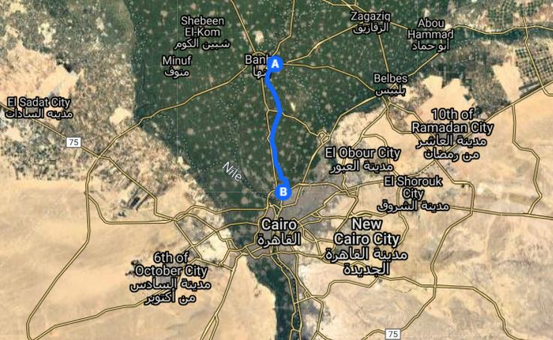
Source: Map created using Google Maps.

Research Approach
In terms of road infrastructure, Egypt ranked 118th among world nations according to the World Economic Forum (2014) when the project was launched. By 2019, it had climbed to 28th place (Ahramonline, 2021). Also, the number of road accidents in Egypt fell by around 30 percent, from 14,403 in 2014 to 9,992 in 2019 (CAPMAS, 2020). While this is all excellent news, the economic impacts to Egypt are also important to measure as improving them motivated the project.
We base our ex-post spatial impacts estimates of the Project on a spatial computable general equilibrium model (SCGE) model for Egypt’s economy (Haddad et al., 2016; Elshahawany, Haddad, and Lahr, 2017). An important feature of this model is that we explicitly estimate the value of freight by origin–destination pair, given national transportation margins. That is, the model roughly accounts for the cost structure of freight by traded commodity. We examine the estimated trade flows before and after the National Road Project. So it is not the trade estimates themselves that matters, but rather how we model estimates of the change in trade.
The modeling structure used in this paper is the manner in an integrated geo-coded transportation network for Egypt with the SCGE model. Thus, if one wants to simulate changes in the network that might affect relative accessibility, an ex post transportation cost matrix can be calculated in addition to the pre-existing ex ante rendition. These, in turn, can then be transformed by the SCGE model via transportation cost functions. This transformation includes two stages: model calibration and simulation.

The Economic Impacts of the National Road Project
Savings in travel time due the constructed new roads that have illustrated in Section 3 shows that almost all regions benefit from the new roads. The single-trip aggregate travel time savings by region range from 5 to 48 hours. We then proceed to calculate the change in transportation costs associated with changes in those travel time. The change in transportation cost among regions is considered the primary direct effect of the National Road Project. We use the change in travel time to calculate the change in cost for domestic and international trade flows using the following two estimated functions.
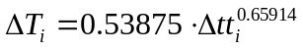, (domestic trade cost function)
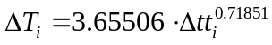 , (international trade cost function)
Where ΔT is the change in transportation cost, Δtt is the change in travel time enabled by the project.
The change in transportation cost to/from all governorates is the economic shock that we enter into our SCGE model. We use the SCGE model to estimate the short- and long-run impacts of the project on both national and regional variables. A distinguishing feature of short- versus long-run simulations is the treatment of the capital stock. Short-run simulations are characterized by an assumption of fixed capital stock. That is, industries’ capital stocks are held at their pre-shock level while, in the long run, policy changes affect capital stocks. We run the two closures (short run and long run) to estimate the impact of the change in transportation cost due to the project on some selected variables.
Our simulations focus on the transportation cost change impact on efficiency gains (real GDP), household consumption and export for the short run. As the reallocation effect become relevant in the long run, we investigate too the change in national investment.

5.1. The Economic Impacts at the National Level
In this section, we discuss the national results of the National Road Project on Egypt’s economy. We focus on the efficiency gains (real GDP) and other national variables that could help in verifying the source of the real GDP change due to the transportation cost change shock to our model. We discuss the results of the GDP components: real household consumption, exports and imports in both short and long runs.
Table 1 presents simulation results for national aggregates in both the short and long runs. Gains in efficiency are realized from the project in both the short and long runs. The export volume is the positive component of the GDP in the short run, while in the long run both real household consumption and export volume improve.
Table 1. Short- and Long-run Effects of Some Selected National Variables
National Level | Short Run | Long Run
Real GDP | 0.288 | 0.269
Real household consumption | -0.429 | 0.355
Export volume | 1.685 | 0.327
Import volume | -1.019 | 0.291
Utility | -0.743 | 0.731
GDP deflator | -3.526 | -0.573
CPI | -2.837 | -0.510

5.2 The Economic Impacts at the Regional Level
In this section, the analysis focuses on project effects at the governorate level in the short run and upon the allocation of economic activity in the long run. We estimate the project impacts on regional growth (change in GRP), regional household consumption, export in both short and long runs and investment only in the long run. Note that, as mentioned earlier and described by Haddad et al. (2016), we model the locus of production and consumption in each governorate at its capital and assume all international trade occurs only through Alexandria.
The model results on selected regional variables are summarized in Tables 2 and 3. The impact on GRP in the short run is positive in almost all governorates due entirely to the substantial rise in exports since it is apparent that household consumption falls in most governorates. Any positive change in household consumption in the short run is limited to those few governorates that had the greatest gains in travel time savings to other regions. Also, exports rise for all governorates.
Table 2. Short-Run Effects on selected Regional Variables (percentage change)
Regions Governorates |  | GRP | Household Consumption | Export
REG_1 | Cairo | 0.614 | -0.302 | 3.275
REG_2 | Alexandria | -0.008 | -1.157 | 0.781
REG_3 | Port Said | 0.119 | -1.325 | 1.269
REG_4 | Suez | 0.798 | -0.508 | 2.193
REG_5 | Damietta | 0.352 | -0.093 | 0.931
REG_6 | Dakahlia | 0.116 | -1.161 | 3.247
REG_7 | Skarkia | 0.521 | 0.234 | 1.538
REG_8 | Kalyoubia | 0.372 | -0.657 | 1.341
REG_9 | Kafr El-Sheikh | -0.114 | -1.306 | 1.326
REG_10 | Gharbia | 0.181 | -0.757 | 1.537
REG_11 | Monufia | 0.386 | -0.356 | 1.347
REG_12 | Beheira | 0.057 | -0.998 | 1.133
REG_13 | Ismailia | 0.260 | -0.777 | 5.135
REG_14 | Giza | 0.208 | -0.963 | 1.665
REG_15 | Beni Suef | 0.460 | 0.487 | 0.853
REG_16 | Fayoum | 0.287 | -0.264 | 1.567
REG_17 | Menia | 0.079 | -0.080 | 0.270
REG_18 | Asyout | 0.231 | 0.007 | 1.175
REG_19 | Suhag | -0.030 | -0.721 | 1.175
REG_20 | Qena | 1.240 | 2.535 | 1.311
REG_21 | Aswan | 0.364 | 0.689 | 0.636
REG_22 | Luxor | 0.635 | 1.147 | 0.824
REG_23 | Red Sea | 0.631 | 1.202 | 3.106
REG_24 | El-Wadi El-Gidid | 0.478 | 1.025 | 0.702
REG_25 | Matrouh | 0.003 | -0.701 | 1.656
REG_26 | North Sinai | -0.154 | -1.296 | 1.578
REG_27 | South Sinai | 2.396 | 4.450 | 3.760

Figure 6. Spatial regional results in the short run.

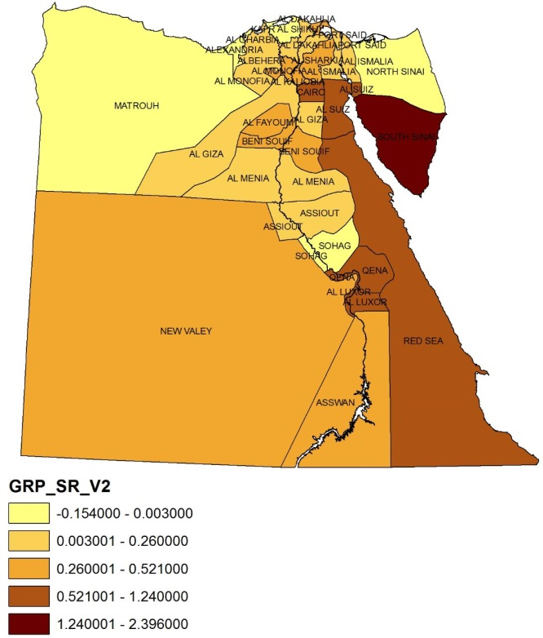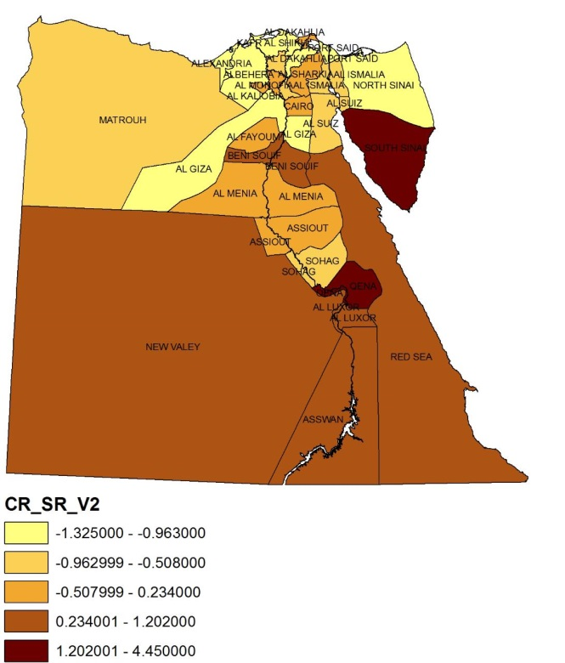

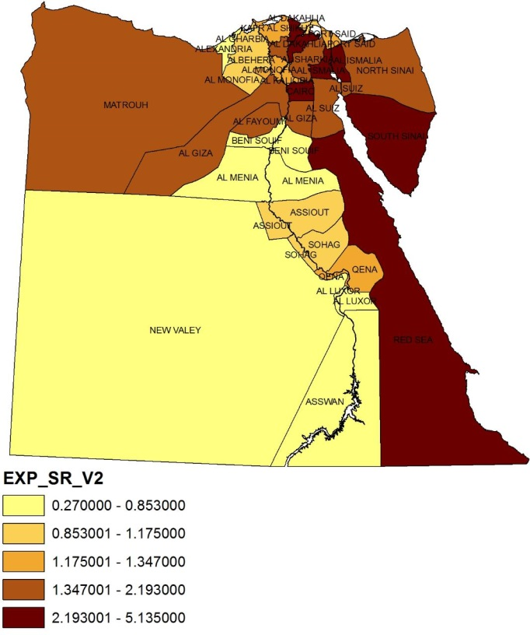
Source: Created using ArcMap.
Figure 6 is a map of the distribution of the short run results across regions. GDP and household consumption impacts across governorates show those governorates that win travel time savings after the construction of the project tend to gain the most efficiency benefits. The impact on export is positive in all regions. However, the regions that gain more export benefits are the regions that locate close to the port (Alexandria) except Red Sea governorate that have the highest change in export volume along with South Sinai.
Table 3. Long-run Effects on Selected Regional Variables (% change)
Regions Governorate |  | GRP | Household Consumption | Investment Expenditures | Export
REG_1 | Cairo | 0.216 | 0.096 | -0.843 | 0.713
REG_2 | Alexandria | 0.100 | 0.383 | 0.107 | -0.005
REG_3 | Port Said | 0.453 | 0.701 | 0.238 | 0.209
REG_4 | Suez | 0.590 | 0.471 | -0.260 | 0.624
REG_5 | Damietta | 0.310 | 0.457 | -0.064 | 0.123
REG_6 | Dakahlia | 0.110 | 0.287 | -0.171 | 0.566
REG_7 | Skarkia | 0.238 | 0.175 | -1.044 | 0.286
REG_8 | Kalyoubia | 0.375 | 0.426 | -0.020 | 0.363
REG_9 | Kafr El-Sheikh | -0.169 | 0.078 | -0.421 | -0.121
REG_10 | Gharbia | -0.308 | -0.210 | -1.064 | 0.026
REG_11 | Monufia | -0.051 | -0.059 | -1.108 | -0.030
REG_12 | Beheira | -0.073 | 0.111 | -0.487 | -0.131
REG_13 | Ismailia | 0.286 | 0.376 | -0.260 | 1.099
REG_14 | Giza | -0.070 | 0.046 | -0.397 | 0.231
REG_15 | Beni Suef | 1.391 | 1.320 | 0.466 | 0.059
REG_16 | Fayoum | 0.469 | 0.482 | -0.191 | 0.154
REG_17 | Menia | 0.311 | 0.643 | 0.194 | 0.145
REG_18 | Asyout | 0.683 | 0.938 | 0.309 | 0.163
REG_19 | Suhag | 0.425 | 0.713 | 0.319 | 0.104
REG_20 | Qena | 1.497 | 1.605 | 0.298 | 0.585
REG_21 | Aswan | 0.872 | 1.203 | 0.473 | 0.369
REG_22 | Luxor | 0.901 | 1.186 | 0.312 | 0.371
REG_23 | Red Sea | 1.482 | 1.620 | 0.670 | 1.389
REG_24 | El-Wadi El-Gidid | 1.146 | 1.734 | 0.769 | 0.258
REG_25 | Matrouh | 0.495 | 0.754 | 0.385 | 0.078
REG_26 | North Sinai | 0.272 | 0.801 | 0.260 | -0.028
REG_27 | South Sinai | 2.115 | 2.087 | -0.321 | 1.632
Figure 7. Spatial Regional Results in the Long Run.
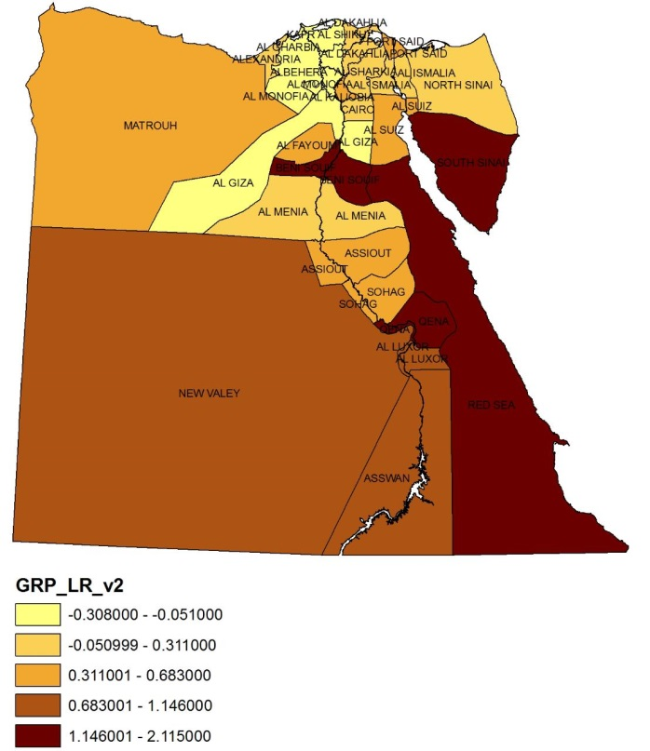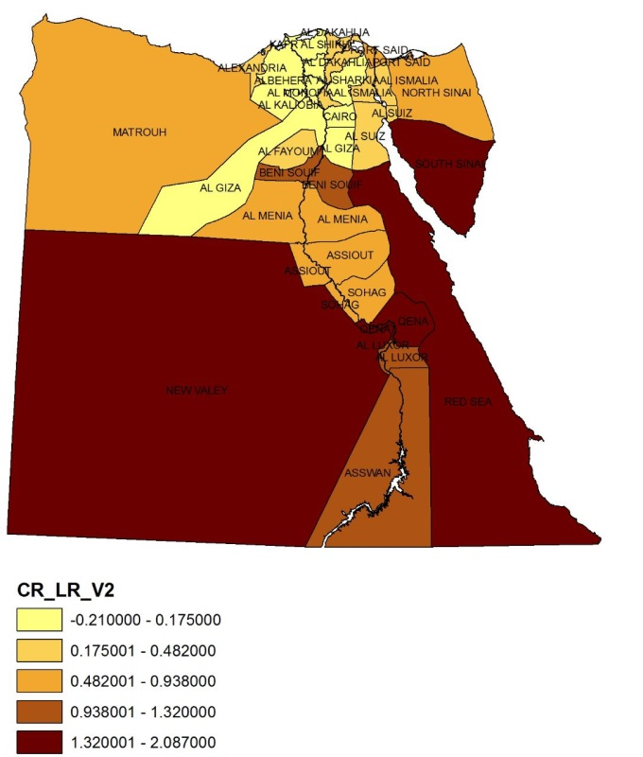
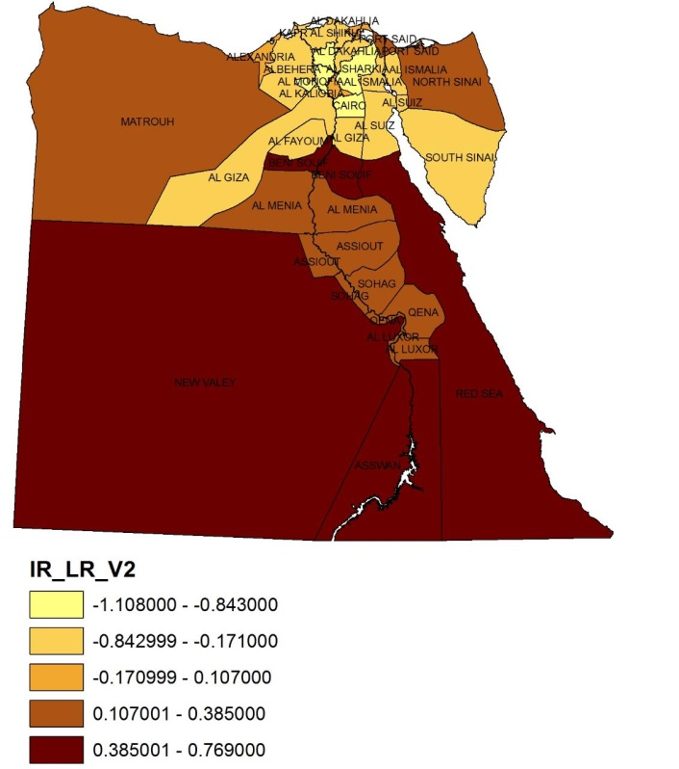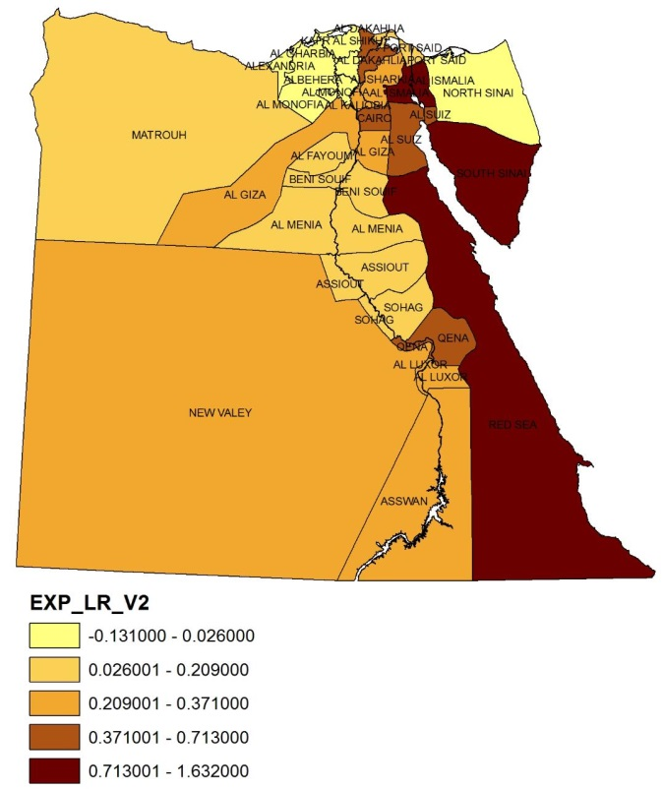
Source: Created using ArcMap
In the long run, the result on household consumption turns positive in most governorates and the result on exports is positive for most of the governorates too. Changes in real investment are positive in almost half of the governorates. Figure 7 sections, shows large positive impacts on GDP, real household consumption, investment and export in all governorates that gain high savings in travel time due to the project (see Figure 1: Qena, Aswan, Luxor, Red Sea, and ElwadiElgaded).

Conclusions
In this paper, we use a spatial CGE model to assess the interregional economic effects of the updated transportation network of Egypt. We focus on possible changes in national economic growth and regional activities. We use a model developed by Haddad et al. (2016) and extended by Elshahawany, Haddad, and Lahr (2017) to examine the economy before and after 4,500 kilometers of new road were enabled by the National Roads Project. We find that, to date, the National Road project has had a strong, positive effect on Egypt’s economy. Both nationally and regionally, the measured impacts are positive, reflecting net gains in efficiency. The governorates that have reaped the most savings in travel time have tend to obtain the greatest economic gains.
Despite the importance of this giant project and its considerable budget, this is the first known set of estimates of the project’s economic impacts. We are certain ours are the first governorate-level estimates. SCGE models akin to ours can help in capture the economic impacts of other transportation improvements such as bridges, railways and river transport. That is, they can support government decisions on such projects.
References.

CAPMAS (2020) The Annual Bulletin of Car and Train Accident, the Central Agency of Mobilization and Statistics.
Elshahawany, Dina.N, Haddad, E. A, Lahr, M.L. (2017), Accessibility, Transpiration Cost, and Regional Growth: a Case Study for Egypt, Middle East Development Journal,DOI:10.1080/17938120.2017.1366773

Egypt Independent ( 2017) Third phase of National Roads Project blueprint ready, Available online at https://egyptindependent.com/third-phase-national-roads-project-blueprint-ready/#:~:text=%E2%80%9CThe%20National%20Roads%20Project%20contributes,New%20Valley%2C%E2%80%9D%20Arafat%20said.

Egypt Independent ( 2018) Regional Ring Road completed, connecting 7 governorates with Cairo: Transport Ministry, Available online in May 2021 at https://egyptindependent.com/regional-ring-road-completed-connecting-7-governorates-with-cairo-transport-ministry/

El-Sahly, A. (2018) ‘Transporting Egypt to the future’, Ahram online, 22 June, Available online in at https://english.ahram.org.eg/NewsContent/4/0/303115/Opinion/Transporting-Egypt-to-the-future.aspx
Haddad, E. A., Lahr, M. L., Elshahawany,D. N., & Vassallo, M. D. (2016). Regional analysis of domestic integration in Egypt: An interregional CGE approach. Journal of Economic Structures, 5(25), 1–33.
Hemada, N. (2021).. (2021) ‘Exiting the Narrow Valley" ... We publish the new road map in 2021’, AkbarElyoum, 3 Feb Available online at https://m.akhbarelyom.com/news/newdetails/3248024/1/%D8%A7%D9%84%D8%AE%D8%B1%D9%88%D8%AC-%D9%85%D9%86 %D8%A7%D9%84%D9%88%D8%A7%D8%AF%D9%8A%D8%A7%D9%84%D8%B6%D9%8A%D9%82-..-%D9%86%D9%86%D8%B4%D8%B1 %D8%AE%D8%B1%D9%8A%D8%B7%D8%A9%D8%A7%D9%84%D8%B7%D8%B1%D9%82-%D8%A7%D9%84%D8%AC%D8%AF%D9%8A%D8%AF%D8%A9-%D9%81%D9%8A-2021
Oxford Business Group (2020). The Report: Egypt 2020, Available online in May 2021 at https://oxfordbusinessgroup.com/purchase-obg-publications?field_country_target_id=54027&field_sector_target_id=All&field_store_product_type_value%5B%5D=report&field_store_product_type_value%5B%5D=chapter&field_store_product_type_value%5B%5D=package&field_store_product_type_value%5B%5D=subscriptions&sort_bef_combine=created+DESC

The Ministry of Transport (2018) The National Road Project, the General Authority for Roads & Bridges and Land Transport, The ministry of Transport.
World Economic Forum. (2015). The Global Competitiveness Report 2014–2015. Available online in May 2021 at https://reports.weforum.org/global-competitiveness-report-2014-2015/

